**2024/2025 School Year - Fostertown 2nd Grade Supply List**

| **1 pair of wired headphones (no rechargeable headphones or ear buds)**  Image result for headphones images | **1 pair of pointed Fiskar Scissors**  Image result for fiskar pointed school scissors | **1 pack of small Elmer’s glue sticks** | **2-3 packs of low odor fine point dry erase markers (black only)**  Image result for dry erase markers |
| --- | --- | --- | --- |
| **1 Mead Primary Journal**  Image result for mead primary journal | **1 Marble Composition Notebook**Image result for marble composition notebook | **2-3 boxes Ticonderoga Pencils** | **2 boxes of Crayola Crayons**Image result for 24 crayola crayons |
| **1 box of Highlighters (yellow or mixed pack)** | **1 box of Crayola colored pencils** | **4 plastic folders**  **1 orange**  **1 green**  **1 red**  **1 blue**  Image result for red plastic folder |  |
|

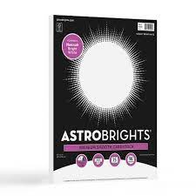

| **Boys**  **1 pack of white cardstock**    **1 box of gallon sized ziploc bags** |  | **2nd Grade Wishlist: *Options for Donation!***  **1 Large Bottle of Hand Sanitizer**  **1 Box of Tissues**  **1 Roll of Paper Towels**  **1 Container of Disinfectant Wipes** |
| --- | --- | --- |
| **Girls**  **1 pack of colored cardstock**    **1 box of sandwich sized ziploc bags.** |