Fostertown School Supply List
Grade Level: Kindergarten 2024-2025
1  PRIMARY  K-2 Notebook | 1 dozen  #2 Ticonderoga sharpened  pencils  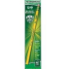 |  | 12  solid small  glue sticks  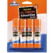 |  | 1  pair of  headphones  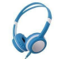 |  | 1  Bookbag  Needs to fit a  folder  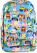 |  | 1  labeled Ziploc bag with  labeled extra clothing for  your child
1  reusable water bottle  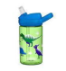 |  | 1  marble  composition  notebook  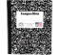 |  | 1  Fiskar scissors (pointed)  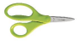 |  | 2  box of 24  Crayola  crayons  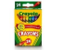 |  | 1  box of 10  Crayola  markers  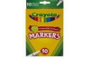

The following items would be appreciated as donations to the classroom.
package of any colored  cardstock paper (8 ½ x 11)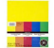 |  | package of white  cardstock paper (8 ½ x 11) 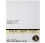 |  | package of any color  copy Paper (8 ½ x 11)  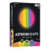
Box of Ziploc Bags – Gallon Size or Sandwich Size  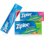 | family size boxes of tissues  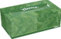 |  | containers of  disinfectant wipes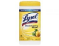 |  | rolls of paper towels
*Please provide a healthy snack for your child each day.
**Please bring supplies to Kindergarten Orientation.
Label the bag with your child’s name and teacher! We will label the supplies! Thank you so much for your support!

